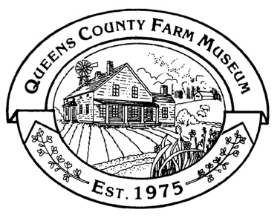
Spring Farm Camp at the QCFM 2026
73-50 Little Neck Parkway
Floral Park, NY 11004
education@queensfarm.org
(718) 347-3276 x106

Participant Permission and Release Form 2026

A participant permission and release form must be filled out and submitted for every participant who will take part in the Queens County Farm Museum’s Spring Farm Camp, held from 8:30am-3:30pm, April 6th through April 10th, 2026.

Parent/Guardian Name (please print):

Participant Name (please print): Age:____ _______

Address: Phone:

Email: Allergies:

- I agree to accept and abide by the rules and regulations of the program as established by the Queens County Farm Museum (QCFM) and to obey the direction of the QCFM’s representatives.

- I understand that video production and/or photography may be conducted during the program. I grant full and irrevocable consent to the Queens County Farm Museum and those acting under its permission or upon its authority, the unqualified right and permission to reproduce, copyright, publish, or otherwise use my photographic likeness.

- I understand that neither medical nor health insurance coverage is supplied by the Queens County Farm Museum and that the participant is responsible for all insurance coverage.

- I understand and expressly assume the risk of any and all damage, injury, death, or harm which may occur to me or my property.

- I forever release and discharge the Queens County Farm Museum, its officers, directors, employees, agents, assigns, and insurers from any and all claims or liability arising out of or in connection with my and/or my child’s participation in the program. This release includes libel, invasion of privacy, negligence, or other fault that result in personal injury, death, or property damage during or in connection with the above program or activities. This release will be construed according to the law of New York State. This Permission and Release Form shall inure the benefit of licensees and assigns of the QCFM, and shall be binding upon myself and/or my child, spouse, and my/his/her heirs, estate, personal representatives, and assigns.

- I understand that visitors are not allowed to bring alcoholic beverages and/or illegal substances into the Queens County Farm Museum at any time. Alcohol and any illegal substances are strictly prohibited on the grounds of the Queens County Farm Museum and in any QCFM buildings. There is no smoking, vaping, or cannabis use allowed on the property.

This document contains a release of claims. Please read it carefully before signing.

I acknowledge that I have received, read, understood, and agreed to the above and I voluntarily sign this Participant Permission and Release Form.

Undersigned:

Participant Print Participant Signature

Parent or Legal Guardian if participant is a minor:

Parent/Guardian Print Parent/Guardian Signature

